**Project Architecture for HR Analytics – Absenteeism**

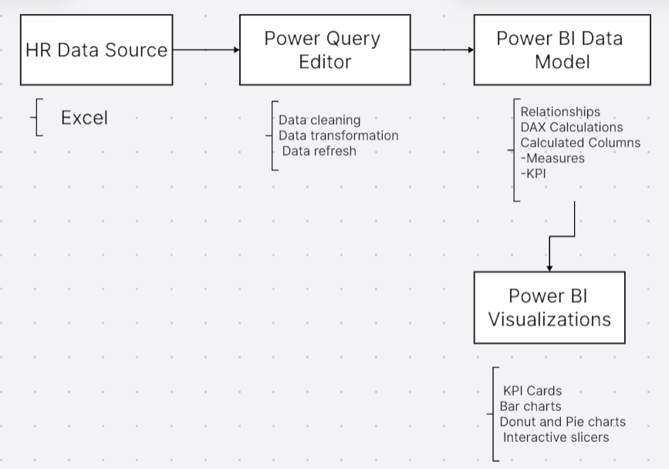

**1. Data Sources:**

* **HR Data (Excel/CSV)**:
  + This contains key employee data such as personal details, job roles, departments, absenteeism hours, length of service, gender, age, and location.
  + Source files could be in formats such as **Excel**.

**2. Data Ingestion:**

* **Power BI Data Load**:
  + Data from various sources like Excel, CSV files, or databases is ingested directly into Power BI.

**3. Data Modelling:**

* **Relationships**:
  + The data model is structured with relationships between different tables such as:
    - **Employee Demographics Table** (Age, Gender, Location, Job Title)
    - **Absenteeism Data** (Absent Hours, Date of Absence)
    - **Department Table** (Department Name, Manager)
    - **Job Title Table** (Job Title, Salary, Grade)
  + These tables are connected by key fields like **Employee ID** and **Job Title** to create a relational data model within Power BI.
* **Data Transformation (Power Query)**:
  + Data transformation is performed using **Power Query**:
    - Clean and format raw data (e.g., ensuring date formats, handling null values).
    - Perform necessary calculations like total absentee hours, average absent hours, and length of service.
  + Calculated columns and measures are also created for performance metrics using DAX (Data Analysis Expressions) for KPIs such as **average absent hours**, **average service length**, etc.

**4. Data Calculation and Metrics (DAX):**

* **Key Measures**:
  + DAX formulas are used to compute critical metrics, such as:
    - Total Employees
    - Average Age
    - Average Length of Service
    - Average Absent Hours
    - Maximum Absent Hours
  + Custom DAX formulas are also used to filter data by department, gender, and city, providing deeper insights into absenteeism patterns.

**5. Visualization Layer:**

* **Power BI Visualizations**:
  + Multiple visualizations are created to provide insights into absenteeism:
    - **KPI Cards**: Used to display key metrics like total employees, average absenteeism, etc.
    - **Bar Charts**: Used to compare absenteeism by department, city, job title, and age group.
    - **Donut Chart**: Shows gender distribution in the workforce.
    - **Pie Charts**: Display absenteeism patterns by department and other categories.
  + **Slicers**: Interactive filters for departments and gender allow users to filter the visualizations and drill down into specific segments of the data.

**6. Interactivity and Filtering:**

* **Slicers and Filters**:
  + The dashboard provides interactive slicers for departments, gender, and city. These slicers allow users to explore the data and get customized views, enabling in-depth analysis of specific segments of the workforce.
  + Drill-through actions are enabled for deeper insights into any KPI or specific area like absenteeism by job role or location.